|  |  |
| --- | --- |
| **Before** | **After** |
|  |  |

**Activity Pictures**

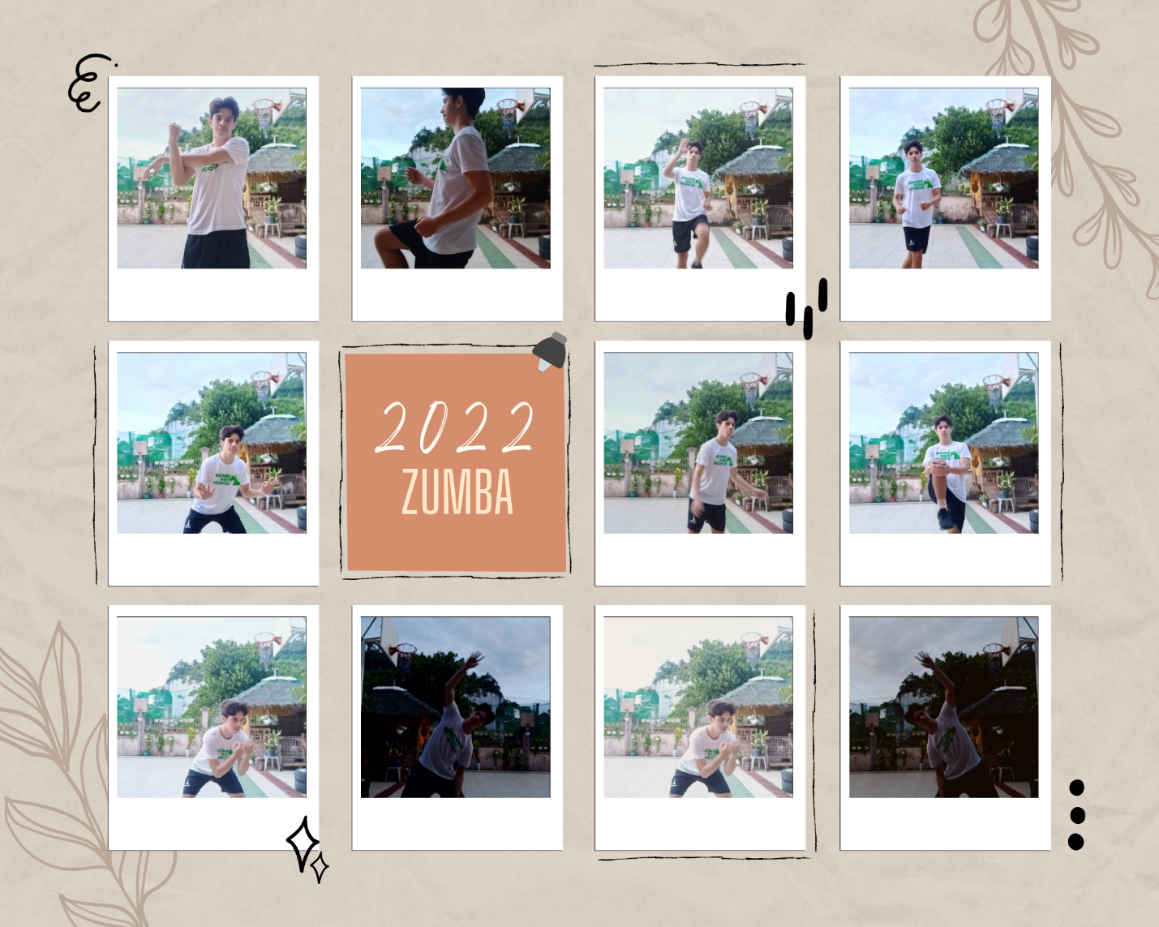

Reflection:

I found Zumba enjoyable despite me not being the type to dance around much. I enjoyed how upbeat it was and quite non-stop. This type of aerobic exercise doesn’t really feel like an exercise due to how fun it is to do. I think Zumba is an excellent cardio workout due to its high and low intervals.

Traditionally, I would much prefer jogging or swimming which I usually did when I was training for Milo Olympics back when I was around 16. But when you have limited space and want to stay at home for your exercise, then Zumba is a great option. I tried to limit my lower body movement because I have an ankle sprain and it’s very difficult to move around. Despite such conditions, I was happy to experience Zumba again since the last time I had it was when I was in JHS when we had Zumba for our flag ceremony in North Campus.